SE EXP 7

Niikunj Makharria 21CE1246 D1

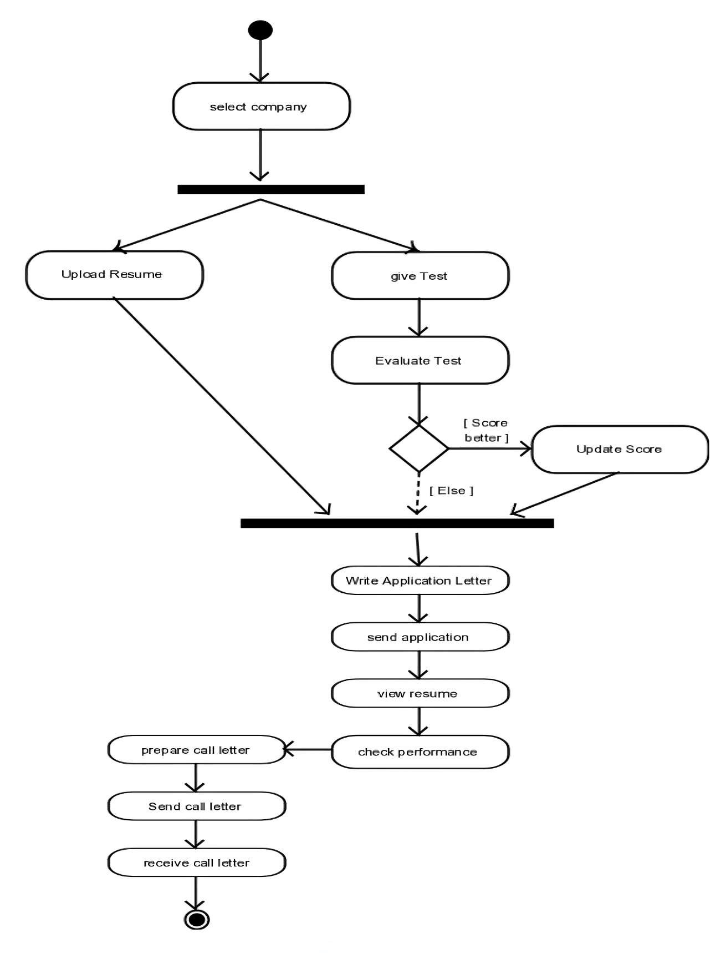

ACTIVITY DIAGRAM

SE EXP 8

Niikunj Makharria 21CE1246 D1

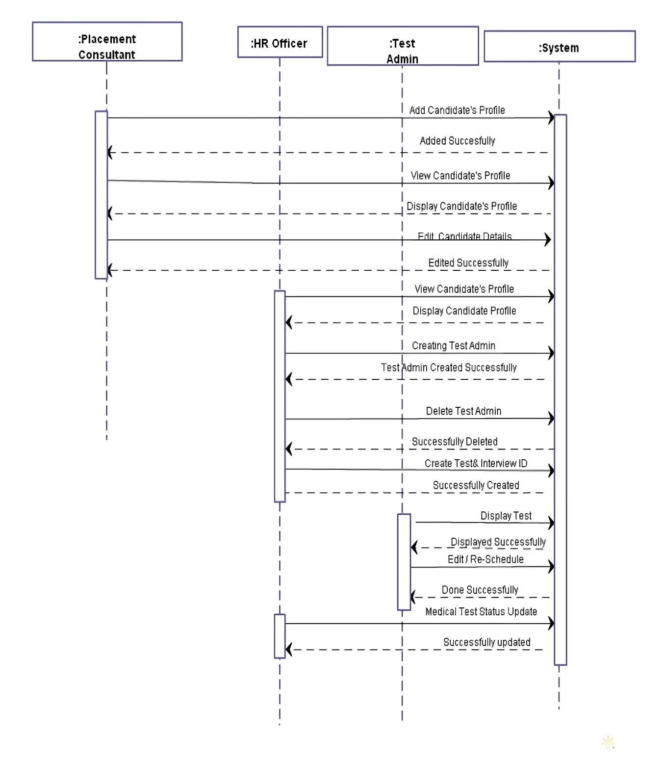

SEQUENCE DIAGRAM

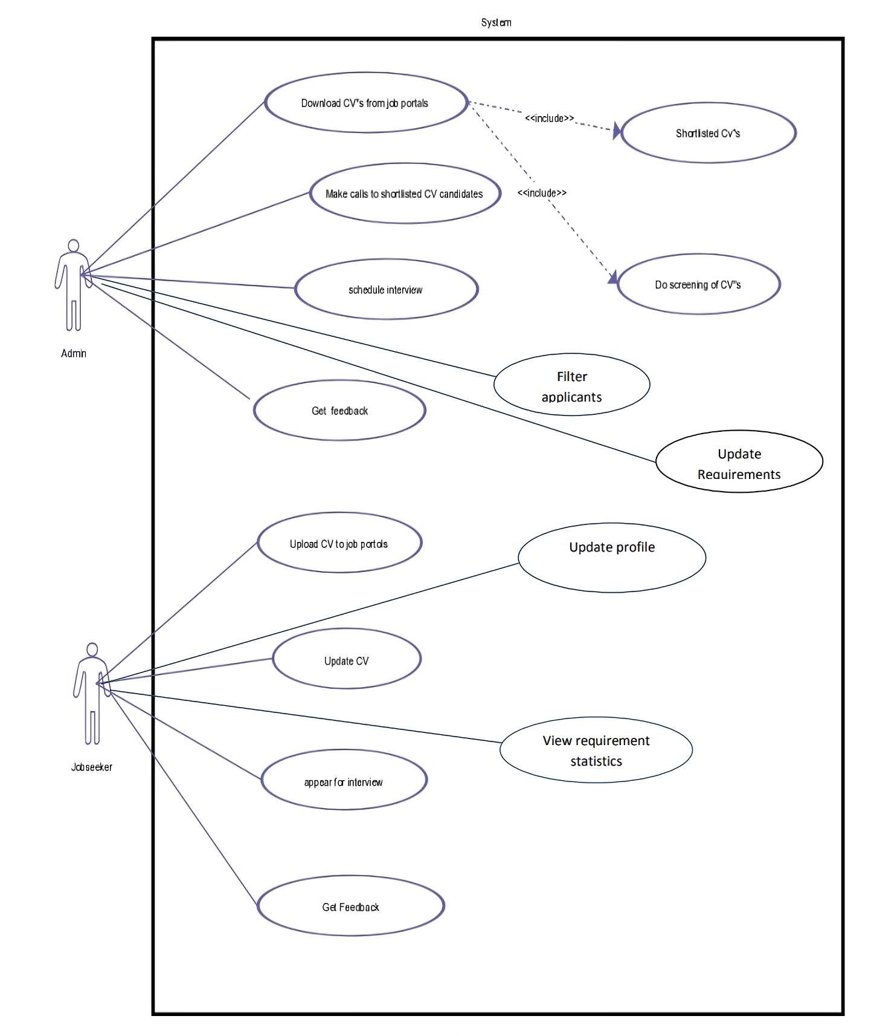

USE CASE DIAGRAM

SE EXP 6

Niikunj Makharria 21CE1246 D1

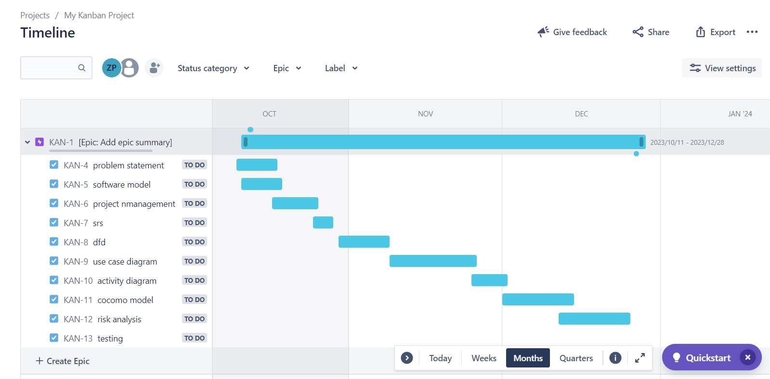

GANTT CHART

SE EXP 4

Niikunj Makharria 21CE1246 D1